Title of Publication Manuscript font Calisto MT; size15; one space; left alignment; maximum 20 word; attract readers and straightforward in describing the content of the article
Author11*, Author22 (Author(s), Calisto MT, bold, 12)
1Universitas Mercu Buana Yogyakarta, Indonesia (Affiliation1, Calisto MT, 10)
2, 3Universitas Mercu Buana Yogyakarta, Indonesia (Affiliation2, Calisto MT, 10)
*author1@umby.com (Affiliation email, Calisto MT, 10)

ABSTRACT (Calisto MT, bold, 11)
An abstract is a single paragraph, without subheadings, indentation or references. It should be an explicit summary of your presentation that states the problem, the objectives, the methods used, and the major results and conclusions. The first part of your abstract should state the problem or issue you set out to solve and explain your rationale for pursuing the research. The purpose of your study is to solve this problem or to add your discipline’s understanding of the issue. Your abstract should indicate the results or outcomes of the work you have done. The abstract should close with a statement of the research implications and contributions to its field. It should be single-spaced in 11-point font Calisto MT. Do not include bullets/lists in the abstract. Be sure to the word limitation for the abstract 175 -275 words. The abstract should be submitted in the format of MS Word (.doc or .docx) document. Keywords should be given leaving one-line space below this text.
Keywords (Calisto MT, bold, 10): paragraph, purpose, word, summary, understanding (Calisto MT, 10)

Introduction (Calisto MT, bold, 12)
The purpose of the Introduction is to stimulate the reader’s interest and to provide pertinent background information necessary to understand the rest of the paper. You must summarize the problem to be addressed, give background on the subject, discuss previous research on the topic, and explain exactly what the paper will address, why, and how.
It must be containing; (a) the latest scientific development of the studied variable; (b) research gap; (c) the researchers’ argument in fulfilling the gap as their commitment to contributing to the development of science; and (d) research objectives. (the total number of pages should be no more than 20% of the overall manuscript pages)
Methods (Calisto MT, bold, 12)
This segment should inform readers of the materials and method that the authors have used for the research. You must describe exactly what you did: what and how experiments were run, what, how much, how often, where, when, and why equipment and materials were used. The main consideration is to ensure that enough detail is provided to verify your findings and to enable the replication of the research. It must be containing: (a) instrumentation, (b) population and methods of sampling; (c) procedure and analysis technique used; (d) description of any approach to ensure validity and reliability. (the maximum page is 20% of the total page of the manuscript).
Results (Calisto MT, bold, 12)
Results should be clear and concise. The results should summarize (scientific) findings and consists of descriptive statistic, assumption test, and hypothesis test, which are then critically analyzed.
Example of Table and Figures
Table 1. Title table
Graduates | Frequency | Percentages
Associate Degrees | 324 | 62.7
Bachelor Degrees | 123 | 35.1
Master Degree | 56 | 20.1
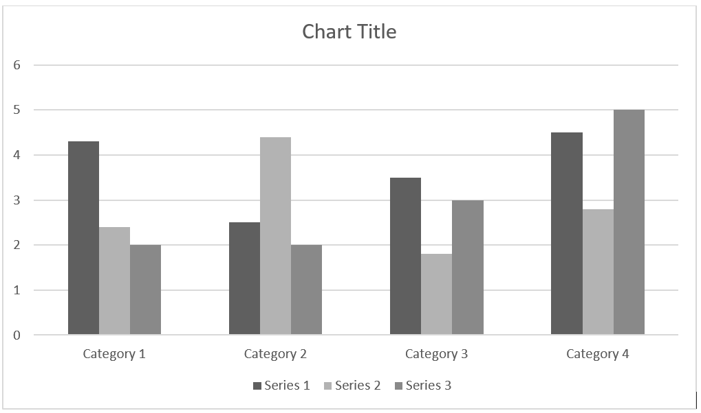

Figure 1. Title figure

Discussions (Calisto MT, bold, 12)
The discussion section contains substantial interpretation of the analysis result and comparison to previous findings based on relevant, recent, and primary literature reviews from the 10 years. It’s must be answer the questions posed in the Introduction, explain how the results support the answers and, how the answers fit in with existing knowledge on the topic. Be careful that your interpretation of the results does not go beyond what is supported by the data. The author may write the research limitations or recommendations contain deficiency in the research and suggestions associated with further ideas from the research. (the total number of pages should be no more than 40% of the overall manuscript pages)

Conclusion (Calisto MT, bold, 12)
A conclusion is not merely a summary of the main topics covered or a re-statement of your research problem, but a synthesis of key points. Conclusion should be brief, clear, and concise, based on the findings and discussion, written in a paragraph form not in numerical.
Discussions (Calisto MT, bold, 12)
The discussion section contains substantial interpretation of the analysis result and comparison to previous findings based on relevant, recent, and primary literature reviews from the 10 years. It’s must be answer the questions posed in the Introduction, explain how the results support the answers and, how the answers fit in with existing knowledge on the topic. Be careful that your interpretation of the results does not go beyond what is supported by the data. The author may write the research limitations or recommendations contain deficiency in the research and suggestions associated with further ideas from the research. (the total number of pages should be no more than 40% of the overall manuscript pages)
Conclusion (Calisto MT, bold, 12)
A conclusion is not merely a summary of the main topics covered or a re-statement of your research problem, but a synthesis of key points. Conclusion should be brief, clear, and concise, based on the findings and discussion, written in a paragraph form not in numerical.
Acknowledgement (Calisto MT, bold, 12)
Acknowledgements to those who support the research (sponsors, respondents, or anyone who provided technical help).
References (APA 6th edition)
We suggest to using software Endnote, Mendeley, Zotero for easily citation. Make sure that all references mentioned in the text are listed in the reference section.
APA FORMAT–6 ^{TH} EDITION

JOURNALS, MAGAZINES, NEWSPAPERS IN PRINT FORMAT General Form
Author, A. A., Author, B. B., & Author, C. C. (Year). Title of article. Title of Journal, xx, xxx-xxx.

NOTE: The journal title and the volume number are in italics. Issue numbers are not required if the journal is continuously paged. If paged individually, the issue number is required and is in regular type in parentheses adjacent to the volume number.

One Author
Williams, J. H. (2008). Employee engagement: Improving participation in safety. Professional Safety, 53(12), 40-45.

Two to Seven Authors [List all authors]
Keller, T. E., Cusick, G. R., & Courtney, M. E. (2007). Approaching the transition to adulthood: Distinctive profiles of adolescents aging out of the child welfare system. Social Services Review, 81, 453-484.

Eight or More Authors [List the first six authors, … and the last author]
Wolchik, S. A., West, S. G., Sandler, I. N., Tein, J.-Y., Coatsworth, D., Lengua, L.,...Griffin, W. A. (2000). An experimental evaluation of theory-based mother and mother-child programs for children of divorce. Journal of Consulting and Clinical Psychology, 68, 843-856.

Magazine Article
Mathews, J., Berrett, D., & Brillman, D. (2005, May 16). Other winning equations. Newsweek, 145(20), 58-59.

Newspaper Article with No Author and Discontinuous Pages
Generic Prozac debuts. (2001, August 3). The Washington Post, pp. E1, E4.

BOOKS, CHAPTERS IN BOOKS, REPORTS, ETC. General Form
Author, A. A. (Year). Title of work. Location: Publisher.

One Author
Alexie, S. (1992). The business of fancydancing: Stories and poems. Brooklyn, NY: Hang Loose Press.

Corporate Author with an Edition and Published by the Corporate Author
American Psychiatric Association. (1994). Diagnostic and statistical manual of mental disorders (4th ed.). Washington, DC: Author.

Anonymous Author
Dorland’s illustrated medical dictionary (31st ed.). (2007). Philadelphia, PA: Saunders.

Chapter in a Book
Booth-LaForce, C., & Kerns, K. A. (2009). Child-parent attachment relationships, peer relationships, and peer-group functioning. In K. H. Rubin, W. M. Bukowski, & B. Laursen (Eds.), Handbook of peer interactions, relationships, and groups (pp. 490-507). New York, NY: Guilford Press.

ERIC Document
Shyyan, V., Thurlow, M., & Liu, K. (2005). Student perceptions of instructional strategies: Voices of English language learners with disabilities. Minneapolis, MN: National Center on Educational Outcomes, University of Minnesota. Retrieved from the ERIC database.(ED495903)

ONLINE JOURNALS, MAGAZINES, NEWSPAPERS General Format – Databases
Author, A. A., Author, B. B., & Author, C. C. (Year). Title of article. Name of Journal, xx, xxx-xxx. doi:xxxxxxxxxx

Article Retrieved from an Online Database
NOTE: Use the article’s DOI (Digital Object Identifier), the unique code given by the publisher to a specific article.

Senior, B., & Swailes, S. (2007). Inside management teams: Developing a teamwork survey instrument. British Journal of Management, 18, 138-
153. doi:10.1111/j.1467-8551.2006.00507.x

NOTE: Use the journal’s home page URL (or web address) if there is no DOI. This may require a web search to locate the journal’s home page. There is no period at the end of web address. Break a long URL before the punctuation.

Koo, D. J., Chitwoode, D. D., & Sanchez, J. (2008). Violent victimization and the routine activities/lifestyle of active drug users. Journal of Drug Issues, 38, 1105-1137. Retrieved from http://www2.criminology.fsu.edu/~jdi/

Article from an Online Magazine
Lodewijkx, H. F. M. (2001, May 23). Individual-group continuity in cooperation and competition under varying communication conditions. Current Issues in Social Psychology, 6(12), 166-182. Retrieved from http://www.uiowa.edu/~grpproc/crisp/crisp.6.12.htm

OTHER ONLINE RESOURCES General Form
Author, A. A. (Year). Title of work. Retrieved from web address

Online Report from a Nongovernmental Organization
Kenney, G. M., Cook, A., & Pelletier, J. (2009). Prospects for reducing uninsured rates among children: How much can premium assistance programs help? Retrieved from Urban Institute website: http:// www.urban.org/url.cfm?ID=411823

Online Report with No Author Identified and No Date
GVU's 10th WWW user survey. (n.d.). Retrieved from http://www.cc.gatech.edu/user_surveys/survey-1998-10/

Web Sites in Parenthetical Citations: To cite an entire Web site (but not a specific document within the site), it is sufficient to give the URL of the site in the text. No entry in the reference list is needed. Example:

Kidpsych is an excellent website for young children (http://
www.kidpsych.org).

REFERENCE CITATIONS IN TEXT

APA utilizes a system of brief referencing in the text of a paper, whether one is paraphrasing or providing a direct quotation from another author’s work. Citations in the text usually consist of the name of the author(s) and the year of publication. The page number is added when utilizing a direct quotation.

Indirect Quotation with Parenthetical Citation
Libraries historically highly value intellectual freedom and patron confidentiality (LaRue, 2007).

Indirect Quotation with Author as Part of the Narrative
LaRue (2007) identified intellectual freedom and patron confidentiality as two key values held historically by libraries.

Direct Quotation with Parenthetical Citation
Darwin used the metaphor of the tree of life "to express the other form of interconnectedness–genealogical rather than ecological" (Gould & Brown, 1991, p. 14).

Direct Quotation with Author as Part of the Narrative
Gould and Brown (1991) explained that Darwin used the metaphor of the tree of life "to express the other form of interconnectedness– genealogical rather than ecological”(p. 14).

CITING SECONDARY SOURCES

When citing in the text a work discussed in a secondary source, give both the primary and the secondary sources. In the example below, the study by Seidenberg and McClelland was mentioned in an article by Coltheart, Curtis, Atkins, & Haller.

Seidenberg and McClelland’s study (as cited in Coltheart, Curtis, Atkins, & Haller, 1993) provided a glimpse into the world

In the references page, you would cite the secondary source you read not the original study.

Coltheart, M., Curtis, B., Atkins, P., & Haller, M. (1993). Models of reading aloud: Dual-route and parallel-distributed- processing approaches. Psychological Review, 100, 589-608.

